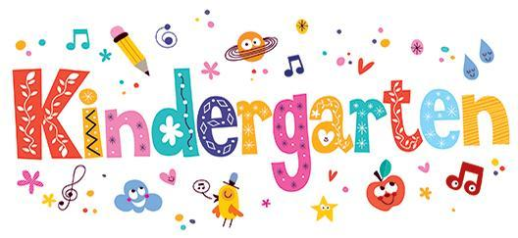

Greetings Parents,

Welcome to Kindergarten! The kindergarten team is very excited and looking forward to the 2024-25 school year. We hope that your scholar is eager to start their learning adventure here at Dunbar Elementary School. Below is a list of supplies that your scholar will need for school and at home. 

